Step 1: Click on the Xvoucher link mail received from support@xvoucher.com to claim the voucher

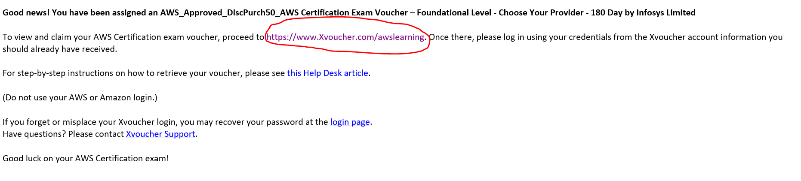

Step 2: Signup to Create a new account for xVoucher login and login with the credentials

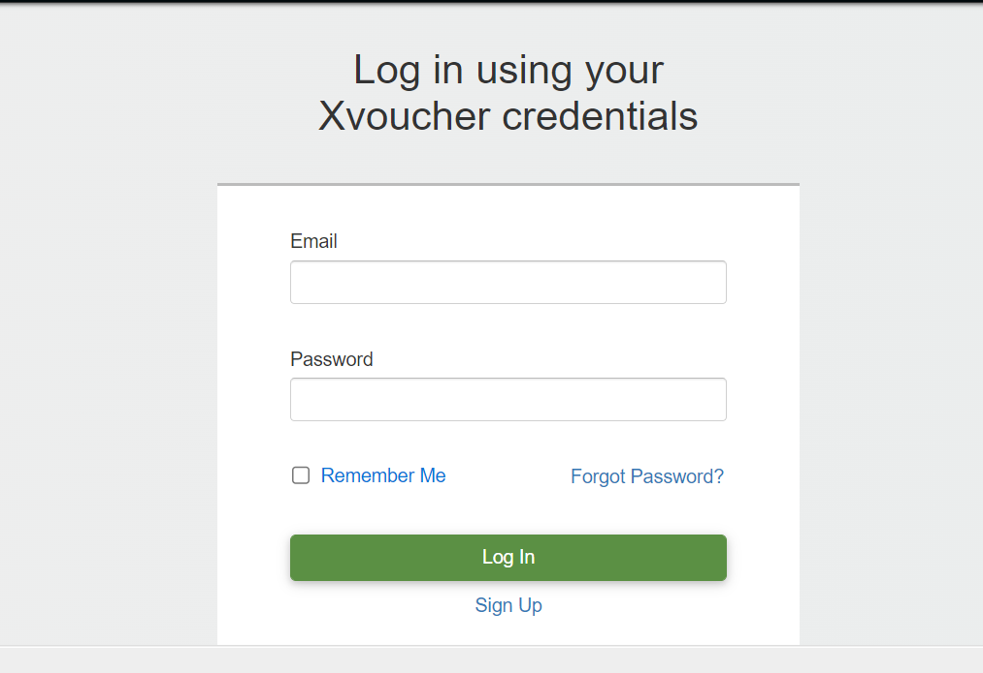

Step 3: You would see the voucher in your Account. Click on it



Step 4 : Click on Choose Item

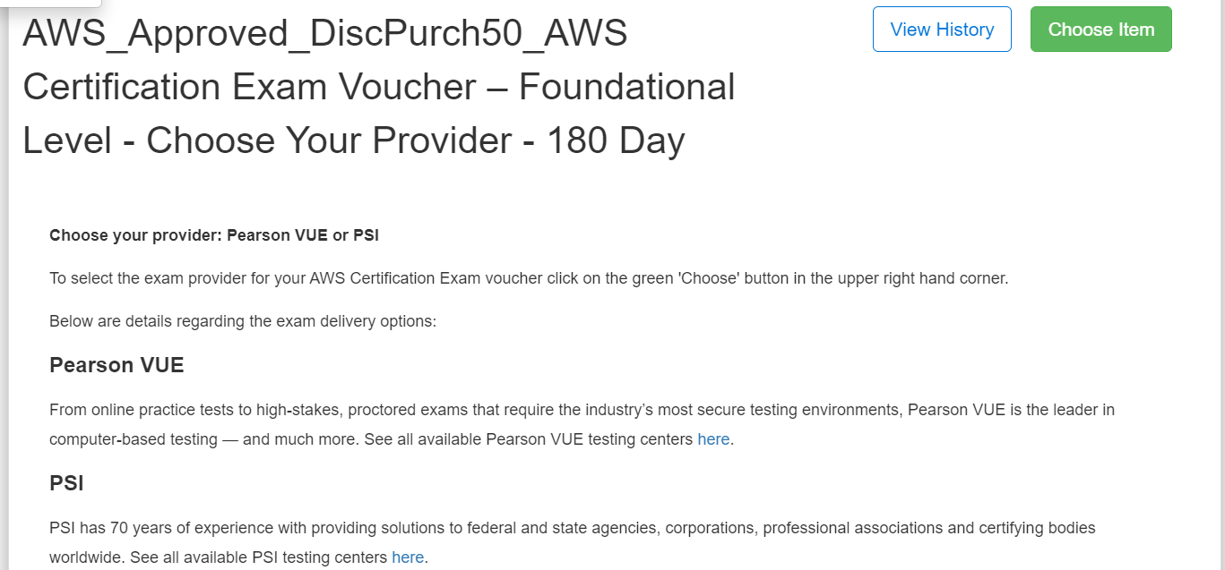

Step 5: Select PSI or PearsonVue vendor to schedule your external exam

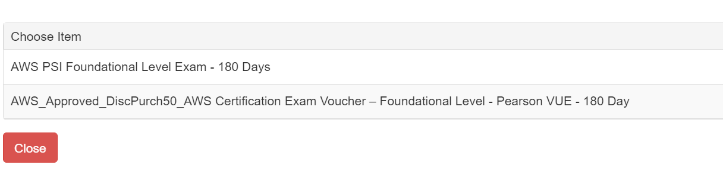

Step 6: Once you have selected the vendor , you will receive mail from xVoucher with the voucher details , along with steps to schedule your external certification exam